**LAPORAN AKHIR PRAKTIKUM**

Mata praktikum : SISTEM BASIS DATA 2

Kelas : 3IA11

Praktikum ke- : 5

Tanggal : 10/05/2025

Materi : Join Table

Npm : 51422161

Nama : MUHAMMAD TARMIDZI BARIQ

Ketua asisten : Muhammad Yasin

Jumlah lembar : 3



**LABORATORIUM TEKNIK INFORMATIKA**

**UNIVERSITAS GUNADARMA**

**2025**

1. select * from users;

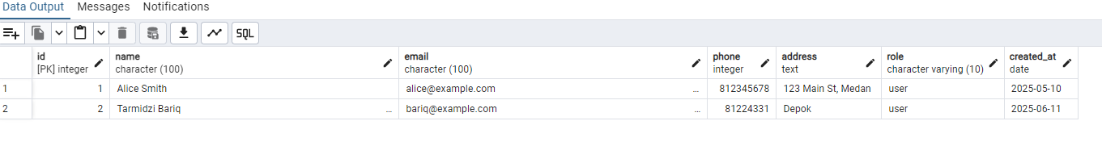

2. left join : Menampilkan semua user, beserta mobil yang dimiliki (jika ada).

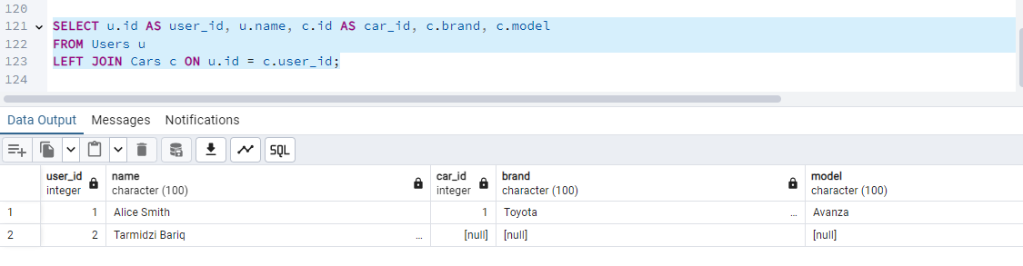

3. Right Join : Menampilkan semua mobil, beserta nama user pemiliknya (jika ada).

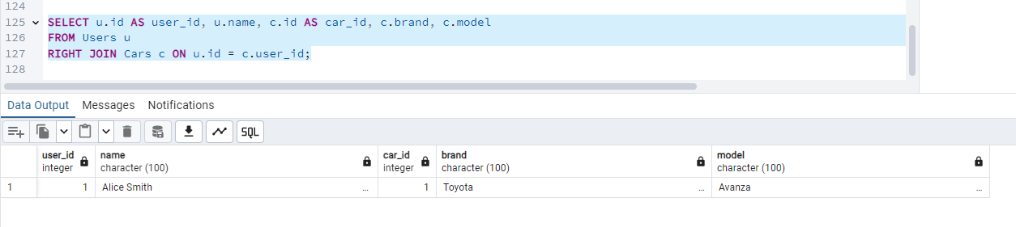

4. Full Join : Menampilkan gabungan semua data user dan mobil, termasuk yang tidak punya relasi.

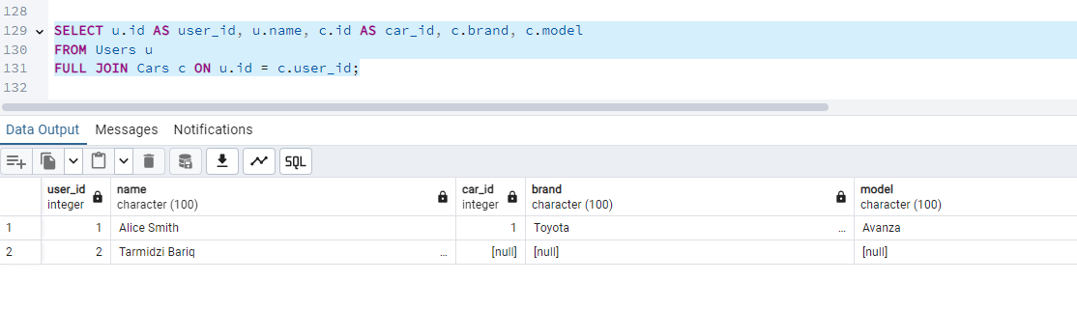

5. Left Join Reviews: Menampilkan semua mobil dan review (jika ada)

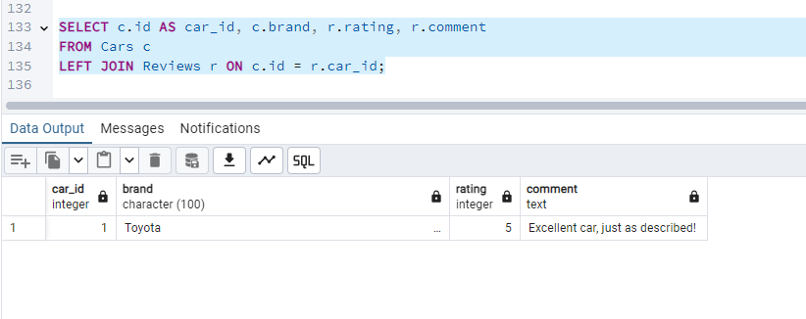

6. update users id 2

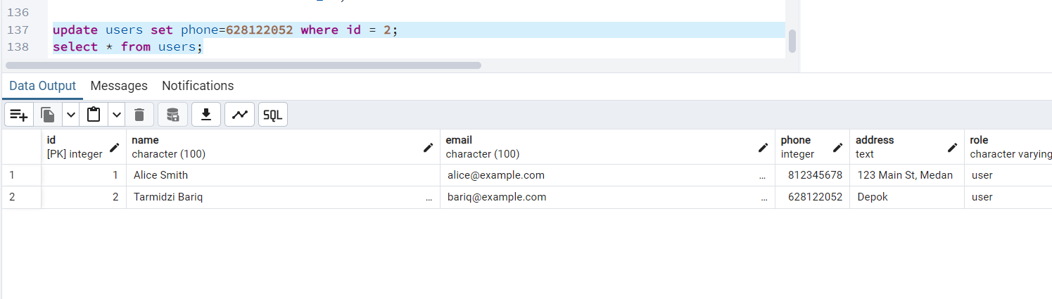

7. delete users id 2

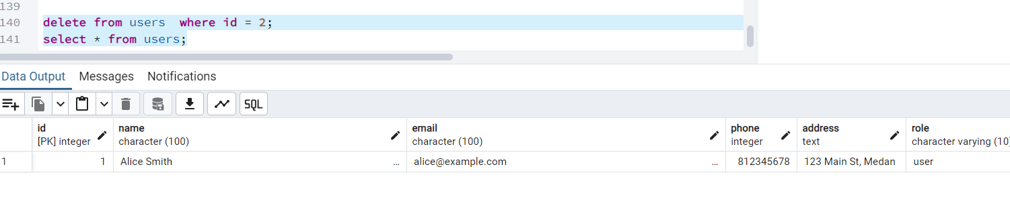

INSERT INTO Users (id, name, email, phone, address, role, created_at)

VALUES (2, 'Tarmidzi Bariq', 'bariq@example.com', 081224331, 'Depok', 'user', '2025-06-11');

select * from users;

INSERT INTO Cars (id, user_id, brand, model, year, price, transmission, service_history, fuel_type, mileage, description, sale_type, status, created_at)

VALUES (1, 1, 'Toyota', 'Avanza', 2020, 180000000, 'automatic', 'Yes', 'Petrol', '25000 km', 'Well-maintained family car', 'showroom', 'available', '2025-05-10');

select * from cars;

INSERT INTO Down_Payments (id, user_id, car_id, amount, payment_status, appointment_date, payment_proof, created_at)

VALUES (1, 1, 1, 50000000, 'confirmed', '2025-05-15', 'proof_001.jpg', '2025-05-10');

select * from down_payments;

INSERT INTO sales_records (id, car_id, buyer_id, saler_id, sale_price, sale_date, status, created_at)

VALUES (1, 1, 1, 1, 180000000, '2025-05-20', 'confirmed', '2025-05-10');

select * from sales_records;

INSERT INTO reviews (id, car_id, user_id, rating, comment, photo_review, status, created_at)

VALUES (1, 1, 1, 5, 'Excellent car, just as described!', 'review_001.jpg', 'approved', '2025-05-10');

select * from reviews;

INSERT INTO offers (id, user_id, brand, mileage, status, transmission, offered_price, year, model, condition, inspection_date, created_at)

VALUES (1, 1, 'Honda', '32000 km', 'pending', 'manual', 150000000, 2019, 'Brio', 'Very good condition, minor scratches', '2025-05-12', '2025-05-10');

select * from offers;

SELECT u.id AS user_id, u.name, c.id AS car_id, c.brand, c.model

FROM Users u

LEFT JOIN Cars c ON u.id = c.user_id;

SELECT u.id AS user_id, u.name, c.id AS car_id, c.brand, c.model

FROM Users u

RIGHT JOIN Cars c ON u.id = c.user_id;

SELECT u.id AS user_id, u.name, c.id AS car_id, c.brand, c.model

FROM Users u

FULL JOIN Cars c ON u.id = c.user_id;

SELECT c.id AS car_id, c.brand, r.rating, r.comment

FROM Cars c

LEFT JOIN Reviews r ON c.id = r.car_id;

update users set phone=628122052 where id = 2;

select * from users;

delete from users where id = 2;

select * from users;